SA Collaborative Partnership for Workplace Health and Wellbeing

Charter and Website Launch
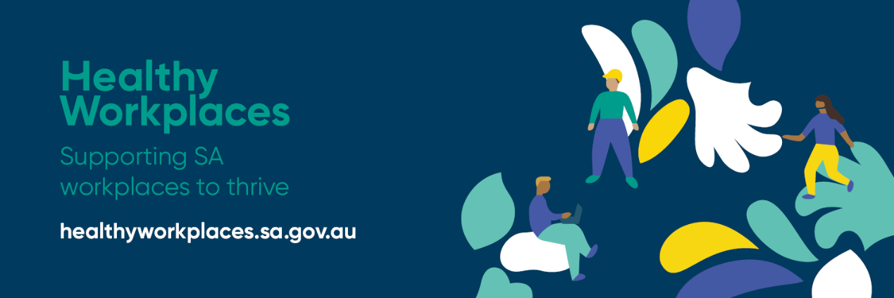
On 28th October 2020, a new charter was signed and the website launched to announce the Collaborative Partnership for Workplace Health and Wellbeing in South Australia.
SISA is a proud member of the Collaborative Partnership together with State government bodies, industry, statutory insurers, academics and unions reflecting a commitment towards improving workplace health, safety and wellbeing across South Australia.
The new Healthy Workplaces website is a trusted site for South Australian employers and workers to access information and practical tools to support workplace health and wellbeing. The website brings together cross-sector information including a range of practical tools and resources to help create a healthy workplace.
With the rates of chronic disease and mental health conditions in the workplace on the rise, it is imperative that we work together to create a coordinated and innovative response to support industries and workplaces to thrive.
The website provides business leaders and workers with the information they need to create a healthy workplace which contributes to greater productivity outcomes, fewer work-related injuries and illnesses, positive workplace culture and improved health and wellbeing outcomes for workers.
The partnership recognises the changing needs of industry so, it encourages workplaces to complete a short survey to highlight their needs. Feedback and input will be used for the development of further information and resources.
Visit and share with your employees the new Healthy Workplaces website for information, tools and resources.

